Super Id : 6401010

WEEK-4 . spring-rest-handson

**REST - Get country based on country code**

**Check for your dependencies**

**You can see you output in the post an or the browser   
use your localhost**

**Here:-8080**

[**http://localhost:8080/countries/in**](http://localhost:8080/countries/in)

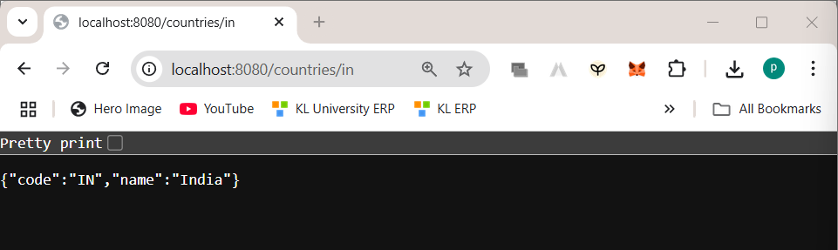

**Add the required files**

**Controller**: com.cognizant.spring-learn.controller.CountryController

package com.cognizant.spring_learn.controller;

import com.cognizant.spring_learn.model.Country;

import org.springframework.web.bind.annotation.*GetMapping*;

import org.springframework.web.bind.annotation.*RestController*;

@*RestController*

public class CountryController {

    @*GetMapping*("/countries/in")

    public Country getCountryIndia() {

        return new Country("IN", "India");

    }

}

**Method Annotation:** @GetMapping("/countries/{code}")  
**Method Name**: getCountry(String code)

package com.cognizant.spring_learn.model;

import javax.xml.bind.annotation.*XmlElement*;

import javax.xml.bind.annotation.*XmlRootElement*;

import java.util.List;

@*XmlRootElement*(name = "countries")

public class Countries {

    private List<Country> countryList;

    @*XmlElement*(name = "country")

    public List<Country> getCountryList() { return countryList; }

    public *void* setCountryList(List<Country> *countryList*) { this.countryList = *countryList*; }

}

**Method Implemetation**: Invoke countryService.getCountry(code)   
**Service Method:**com.cognizant.spring-

learn.service.CountryService.getCountry(String code)  
package com.cognizant.spring_learn.service;

import com.cognizant.spring_learn.model.Country;

import org.springframework.stereotype.*Service*;

import javax.xml.parsers.DocumentBuilderFactory;

import org.w3c.dom.*;

import java.io.InputStream;

import java.util.ArrayList;

import java.util.List;

@*Service*

public class CountryService {

    public Country getCountry(String *code*) {

        List<Country> countries = loadCountriesFromXML();

        return countries.stream()

                .filter(*c* *->* *c*.getCode().equalsIgnoreCase(*code*))

                .findFirst()

                .orElse(null);

    }

    private List<Country> loadCountriesFromXML() {

        List<Country> countries = new ArrayList<>();

        try {

            InputStream inputStream = getClass().getResourceAsStream("/country.xml");

            Document doc = DocumentBuilderFactory.newInstance().newDocumentBuilder().parse(inputStream);

            NodeList nodes = doc.getElementsByTagName("country");

            for (*int* i = 0; i < nodes.getLength(); i++) {

                Element element = (Element) nodes.item(i);

                Country country = new Country();

                country.setCode(element.getElementsByTagName("code").item(0).getTextContent());

                country.setName(element.getElementsByTagName("name").item(0).getTextContent());

                countries.add(country);

            }

        } catch (Exception e) {

            e.printStackTrace();

        }

        return countries;

    }

}